Digital Readiness
of Vocational Educational
Institutions
in an Inclusive Environment

PR2: Handbook
Chapter 4
Content
1. Tools Collection 4
1.1 Animoto 4
1.2 Anton Lernapp 4
1.3 Avail 5
1.4 Blackboard Collaborate 5
1.5 Blackboard Learn 6
1.6 Bookcreator 7
1.7 Bubbl 8
1.8 Canva 9
1.9 Classroomscreen 10
1.10 E-klase 11
1.11 EdPuzzle 12
1.12 EduPad 13
1.13 Falstad 14
1.14 Google drive/docs 15
1.15 Google Translate 16
1.16 Google Workspace 17
1.17 Historiana 18
1.18 JAMBA: Job-searching platform 19
1.19 Kahoot! 19
1.20 Learningapps 20
1.21 Liveworksheets 21
1.22 Mentimeter 22
1.23 Microsoft Office (Microsoft 365) 23
1.24 Microsoft Teams 24
1.25 Miro 25
1.26 Moodle 26
1.27 Moodle IB online academy 27
1.28 Padlet 28
1.29 Paint 29
1.30 PDF 30
1.31 Phet 31
1.32 Quizlet 32
1.33 Smart learning suite online Lumio 33
1.34 Text-to-speech and speech-to-text functions 34
1.35 ThingLink 35
1.36 Viber 36
1.37 WhatsApp 37
1.38 Zoom 38

1. Tools Collection

Animoto
- Type: Video maker
- Target Group: Students with Mental Disabilities
- Language available: English
- Membership/Costs: Freemium
- Link: https://animoto.com/k/welcome

Anton Lernapp
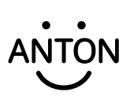
- Type: Mobile Application
- Target Group: Learners with disabilities
- Language available: English
- Link: https://anton.app/de/

Avail
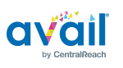
- Type: Mobile Application
- Target Group: Learners with disabilities
- Language available: English
- Additional Information: This is an app for individualized support.
- Link: https://availsupport.com/

Blackboard Collaborate
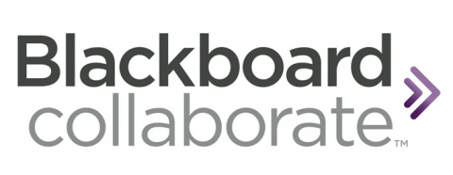
- Type: Teleconference Tool
- Target Group: Higher education students
- Language available: English
- Membership/Costs: Paid

Blackboard Learn
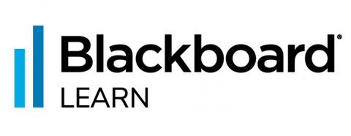
- Type: Learning management system
- Target Group: Higher education students
- Language available: English
- Membership/Costs: Paid

Bookcreator
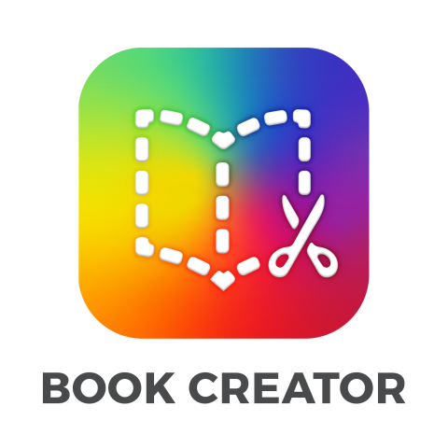
- Type: Content creation platform
- Target Group: People of all ages with different types of congenital or acquired disabilities
- Language available: English
- Membership/Costs: Freemium
- Link: https://bookcreator.com/

Bubbl
- Type: Online Mind Map
- Target Group: People of all ages with different types of congenital or acquired disabilities
- Language available: English
- Membership/Costs: Freemium
- Link: https://bubbl.us/

Canva
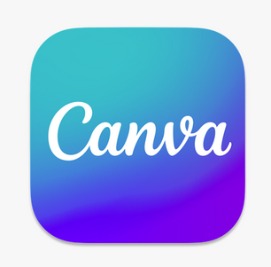
- Type: Graphic design tool
- Target Group: Students with mental disabilities
- Language available: English, Russian, Latvian
- Membership/Costs: Freemium
- Link: https://www.canva.com

Classroomscreen
- Type: Digital board
- Target Group: People of all ages with different types of congenital or acquired disabilities
- Language available: English
- Membership/Costs: Freemium
- Link: https://classroomscreen.com/

E-klase
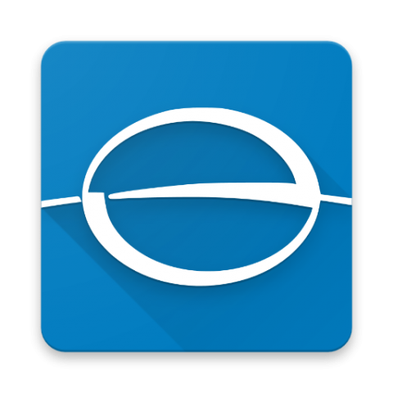
- Type: Electronic school management system
- Target Group: People of all ages with different types of congenital or acquired disabilities
- Language available: Latvian
- Membership/Costs: Free
- Link: https://www.e-klase.lv/

EdPuzzle
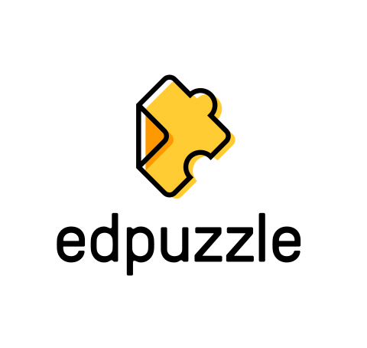
- Type: Interactive video lessons
- Target Group: People of all ages with different types of congenital or acquired disabilities
- Language available: English
- Membership/Costs: Free
- Link: https://edpuzzle.com

EduPad
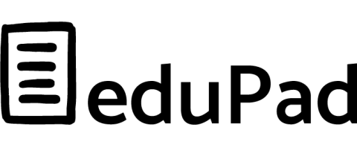
- Type: Software platform
- Target Group: Teachers/ Students/ Educational Institutions
- Language available: English, Spanish
- Membership/Costs: Freemium
- Additional Information: Edupad is an online education platform that helps teachers and students collaborate on projects and assignments. It offers a range of tools and features such as digital textbooks, video conferencing, digital whiteboards, and assessment and tracking systems. It's a collaborative text editor that allows multiple people to work simultaneously, in a real time. A login or registration is not necessary. Enables sharing via a link and sending it in an e-mail. Document history can be tracked, there is a chat option and export capabilities to pdf and word. Up to 20 people can work, and the information is available through the link for up to 1 year, after which it is automatically deleted.
- Link: https://edupad.ch/

Falstad
- Type: Circuit Simulator
- Target Group: Students
- Language available: English
- Membership/Costs: Free
- Link: https://www.falstad.com

Google drive/docs
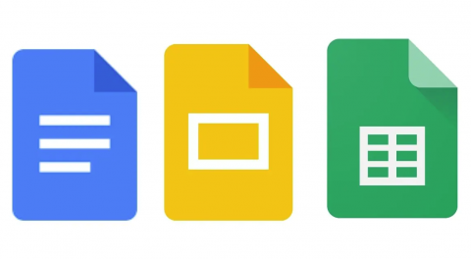
- Type: Cloud
- Target Group: All
- Language available: German, English, Spanish, French, Italian, Russian, Latvian
- Membership/Costs: Freemium
- Link: https://drive.google.com

Google Translate
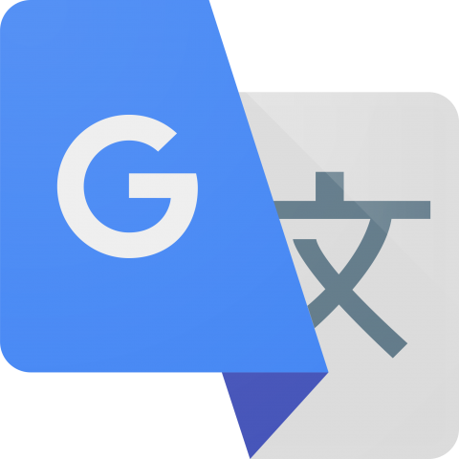
- Type: Service for translation
- Target Group: Students with Mental Disabilities
- Language available: German, English, Spanish, French, Italian, Russian, Latvian
- Membership/Costs: Free
- Link: https://translate.google.com

Google Workspace
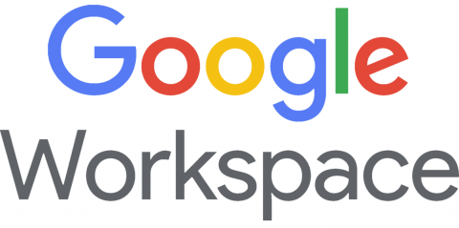
- Language available: English

Historiana
- Type: E-activity builder
- Target Group: Students
- Language available: English
- Membership/Costs: Freemium
- Link: https://historiana.eu/builder

JAMBA: Job-searching platform
- Type: Website
- Language available: English

Kahoot!
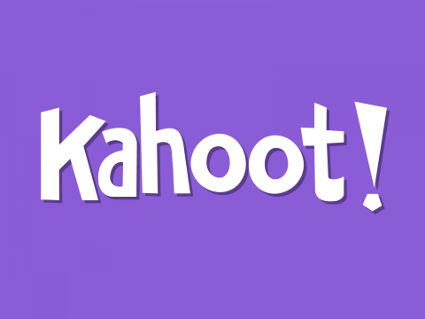
- Type: Game-based learning platform
- Target Group: Students with Mental Disabilities
- Language available: English
- Membership/Costs: Freemium
- Link: https://kahoot.com

Learningapps
- Type: online activities/content creator/ online tool to create learning moduls
- Target Group: Teachers and Students
- Language available: German, English, Spanish, French, Italian, Russian, Latvian
- Membership/Costs: Free
- Link: https://learningapps.org/

Liveworksheets
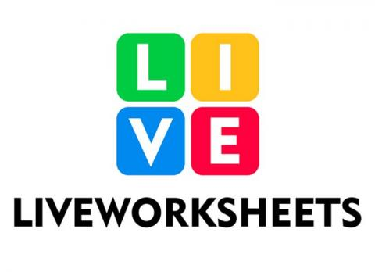
- Language available: English

Mentimeter
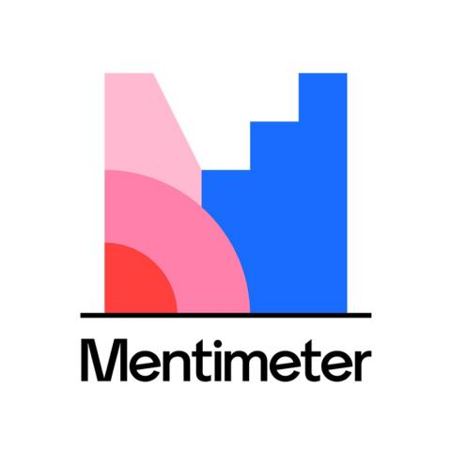
- Type: Software platform, audience response tool
- Target Group: Teachers/ Trainers / Students/ Bussiness professionals, People of all ages with different types of congenital or acquired disabilities
- Language available: German, English, Spanish, French, Italian, Russian
- Membership/Costs: Freemium available
- Additional Information: Mentimeter is an online platform for interactive presentations and meetings. It can be used to create interactive polls, quizzes and surveys, and to collect and visualize audience responses in real time. It also includes features such as word clouds, heat maps and image slides.
Mentimeter also offers integration with popular services such as Slack, Microsoft Teams and Zoom, allowing users to embed interactive sessions into virtual meetings. It is also available as a mobile app for iOS and Android devices
- Link: https://www.mentimeter.com

Microsoft Office (Microsoft 365)
- Type: Productivity software
- Target Group: Students
- Language available: German, English, Spanish, French, Italian, Russian, Latvian
- Membership/Costs: Free
- Additional Information: useful for individual work
- Link: https://www.office.com

Microsoft Teams
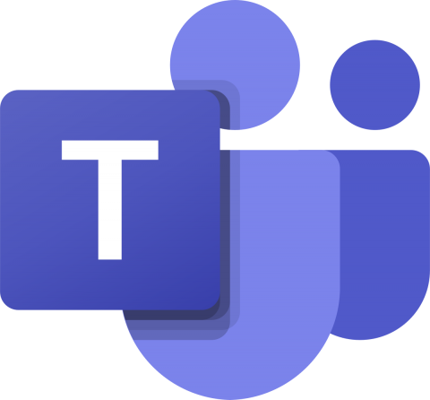
- Type: Communication platform
- Target Group: Students with Mental Disabilities
- Language available: German, English, Spanish, French, Italian, Russian, Latvian
- Membership/Costs: Freemium
- Link: https://www.microsoft.com/en-us/microsoft-teams/group-chat-software

Miro
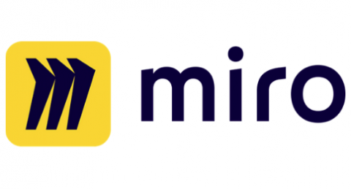
- Type: Software platform, Digital board
- Target Group: Еmployees/Students/ Trainees, 1-3-Year students (from 10-12)
- Language available: German, English, Spanish, French, Italian, Russian
- Membership/Costs: Freemium
- Additional Information: Miro is an online collaboration platform that helps teams collaborate and create visual content. It offers a range of features such as virtual whiteboards, video conferencing, team chat, and brainstorming tools. It's online whiteboard for real-time collaboration. It bring teams together, anytime and anywhere. Miro is easy to use and works with all types of devices from interactive displays to tablets and smart phones. It allows users to present ideas, collaborate both asynchronously and in real time. The whiteboard can be used to brainstorm ideas, facilitate meetings, run agile workshops and classes.
- Link: https://miro.com

Moodle
- Type: Learning management system
- Target Group: Students with Mental Disabilities, HE students
- Language available: German, English, Spanish, French, Italian, Russian, Latvian
- Membership/Costs: Free
- Link: https://moodle.org/

Moodle IB online academy
- Type: Learning management system
- Target Group: Teachers and Students
- Language available: German, English, French, Turkish, Arabic, Ukrainian
- Membership/Costs: Free
- Link: https://moodle.ib-online-akademie.de/login/index.php

Padlet
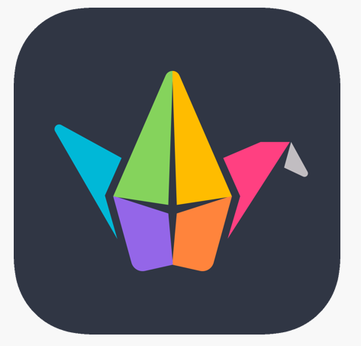
- Type: Digital canvas
- Target Group: Students
- Language available: English, Russian, Latvian
- Membership/Costs: Free
- Link: https://padlet.com

Paint
- Type: Simple raster graphic editor
- Target Group: Students
- Language available: German, English, Spanish, French, Italian, Russian, Latvian, Turkish, Arabic, Ukrainian
- Membership/Costs: Free
- Link: Windows OS standard software

PDF
- Language available: German, English, Spanish, French, Italian, Russian, Latvian, Turkish, Arabic, Ukrainian
- Membership/Costs: Free

Phet
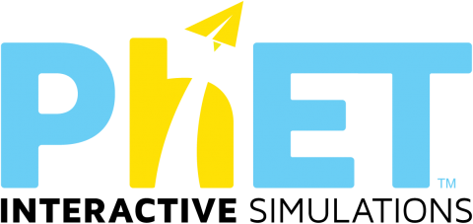
- Type: Interactive Simulations for Science and Math
- Target Group: Students with Mental Disabilities
- Language available: English
- Membership/Costs: Freemium
- Link: https://phet.colorado.edu

Quizlet
- Type: Flashcards
- Target Group: Students
- Language available: English, Russian
- Membership/Costs: Freemium
- Link: https://quizlet.com/en-gb

Smart learning suite online Lumio
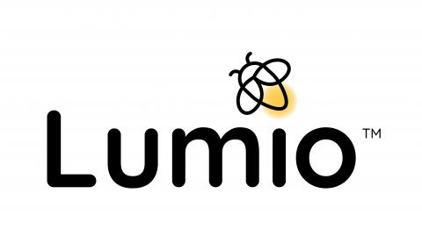
- Type: Learning management system
- Target Group: Teachers and Students
- Language available: German, English, Spanish, French, Italian, Dutch
- Membership/Costs: Freemium
- Link: https://www.smarttech.com/de-de/lumio/pricing

Text-to-speech and speech-to-text functions
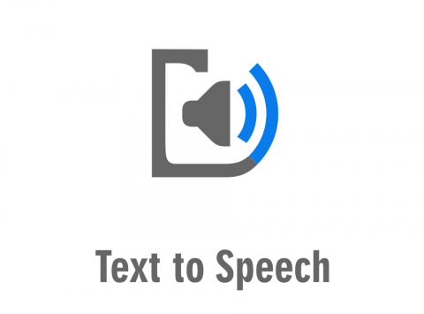
- Language available: English

ThingLink
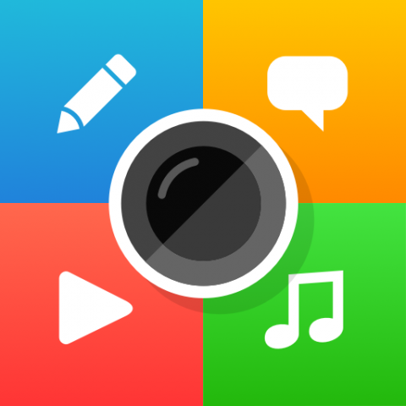
- Type: Creating audiovisual learning materials and digital stories
- Target Group: Students
- Language available: English
- Membership/Costs: Freemium
- Link: https://www.thinglink.com/en-us/edu

Viber
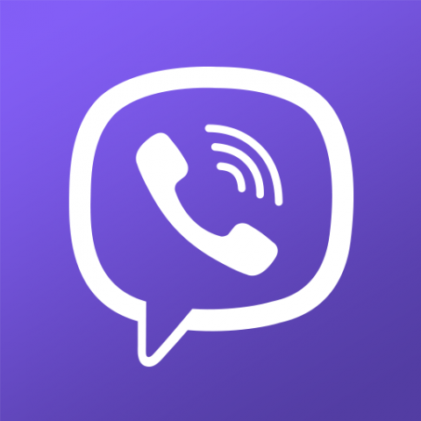
- Type: Messenger
- Target Group: 1-3-Year students (form 10-12)
- Language available: English, Russian, Latvian
- Membership/Costs: Free
- Link: https://www.viber.com/en/

WhatsApp
- Type: Messenger
- Target Group: People of all ages with different types of congenital or acquired disabilities
- Language available: English, Russian, Latvian
- Membership/Costs: Free
- Link: https://web.whatsapp.com

Zoom
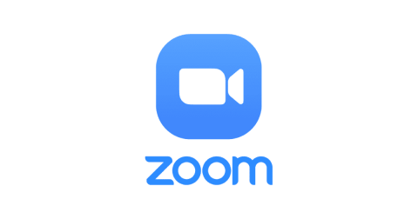
- Type: Teleconference tool
- Target Group: 1-3-Year students (form 10-12)
- Language available: English, Russian, Latvian
- Membership/Costs: Freemium
- Link: https://zoom.us

Funded by the European Union. Views and opinions expressed are, however, those of the author(s) only and do not necessarily reflect those of the European Union or the European Commission Neither the European Union nor European Commission can be held responsible for them.

Copyright © DIG-i-READY consortium 2023 All rights reserved.

